Accommodation
Participants are free to select the accommodation that suits them the best in Helsinki-Espoo area.

Recommended Hotels in Espoo and Helsinki
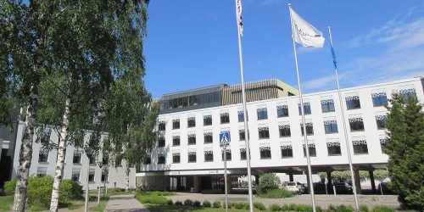

Radisson Blue Espoo (https://www.radissonblu.com/en/hotel-espoo)
The hotel is located on the seaside in Otaniemi, just over 1 km from the event venue, Maarintie 8. The prices per night are 135 € and 155 € for single and double rooms, respectively.
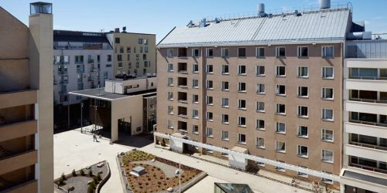

Hostel Domus Academica (https://www.hostelacademica.fi/)
The cost-effective hostel is located in Helsinki, within walking distance from the city centre. The distance to Otaniemi is about 9 km and takes a little over 20 min by metro. The prices per night are 63 € and 72 € for single and double rooms, respectively. The prices do not include breakfast.

