WORKSHOP
“Open Questions on Gloss Measurement”
&

4th Project meeting of BiRD

October 23rd to 25th, CSIC
at the
Consejo Superior de Investigaciones Científicas (CSIC)
121 Serrano Street
28006 Madrid

Location of the Consejo Superior de Investigaciones Cientificas (CSIC)
The CSIC is located near Plaza de la República Argentina. It can be reached either by:
- Subway: República Argentina (L-6) and Nuevos Ministerios (L-6, L- 8 and L-10). See file “Map Metro_Madrid.pdf”.
- Renfe Commuter trains: Nuevos Ministerios Station (Suburban trains, labeled CERCANIAS in Spanish: C1, C2, C3, C4, C7 and C8).
- EMT Buses: Lines 16, 19 and 51.
To use the bus and subway it is necessary to own a transportation card where pre-paid tickets can be loaded. The card can be obtained at the machines in the subway stations and at some kiosks.
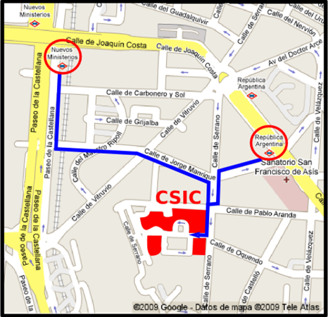
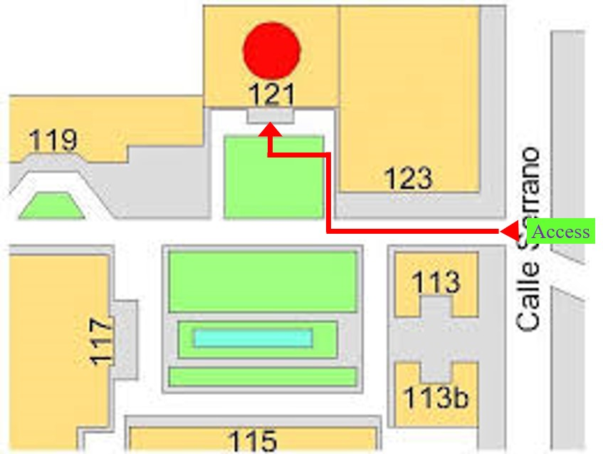
Map of the CSIC site. The meeting will take place in building 121.
Hotels:
See file “Hotels_near_CSIC_Madrid.docx”. Note: CSIC has not arrangements with any hotel. You must handle the booking on your own. A situation map with hotels is shown below.

Tourist information:
See file “Tourist Map Metro_Madrid.pdf” or visit https://www.esmadrid.com/en.

Travel information
Public transportation from the airport:
From airport “Adolfo Suarez Madrid-Barajas”: The best connection is by subway line 8 to Nuevos Ministerios station.
There is also a suburban train, C1. The journey to Nuevos Ministerios takes about 21 minutes. Suburban train to Madrid leave Adolfo Suarez Madrid-Barajas (only from Terminal 4, T4) from approximately 5:56 am until 10:55 pm. See timetable: http://www.renfe.com/viajeros/cercanias/madrid/
The price for a taxi ride from the Barajas airport to the centre of Madrid is 30 € one way (flat fare).
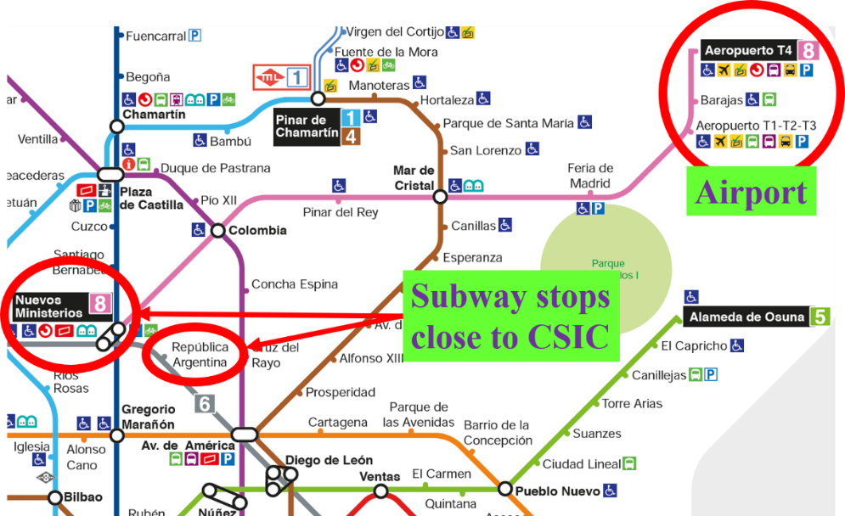
Subway map
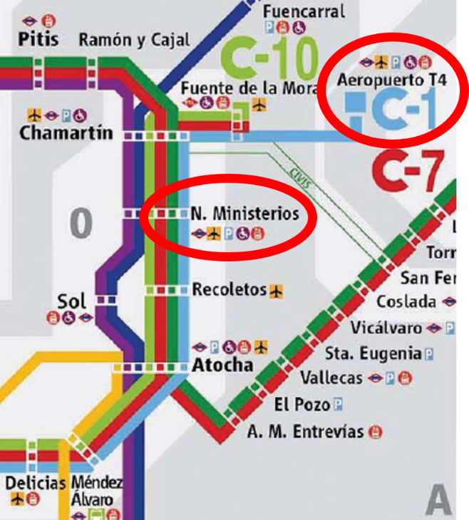
Suburban train map

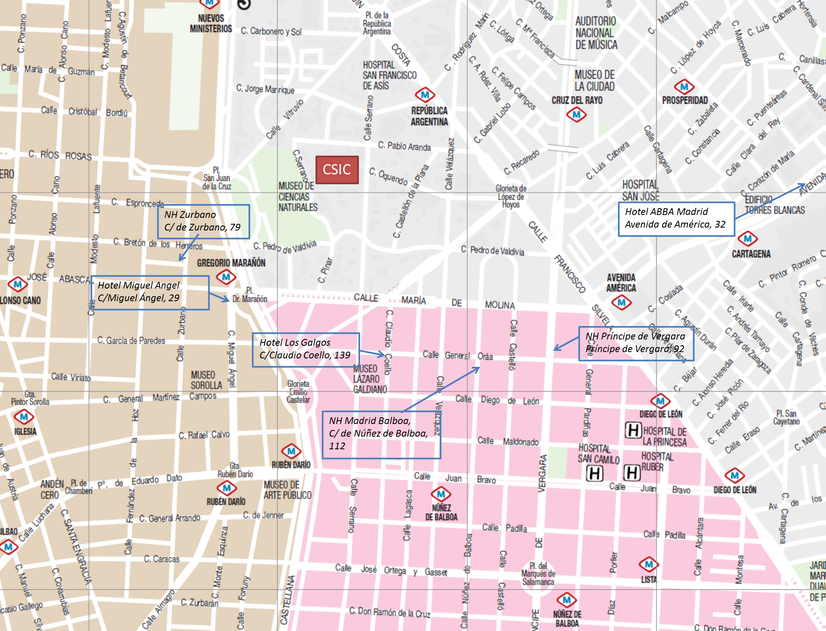
NH Zurbano
C/de Zurbano, 79
Hotel Miguel Ángel
C/Miguel Ángel, 29
Melia Madrid Serrano
C/Claudio Coello, 139
NH Madrid Balboa
C/ de Núñez de Balboa, 112
NH Principe de Vergara
C/ del Principe de Vergara, 92
Hotel ABBA Madrid
Avenida de América, 32
NH Madrid Chamberi
C/de Breton de los Herreros, 29
NH Collection Madrid Abascal
C/José Abascal, 47
Hotel Hesperia Madrid
Paseo de la Castillana, 57
Tryp Madrid Chamberi
C/José Abascal, 8

